Execute pipeline
To execute any previous pipeline
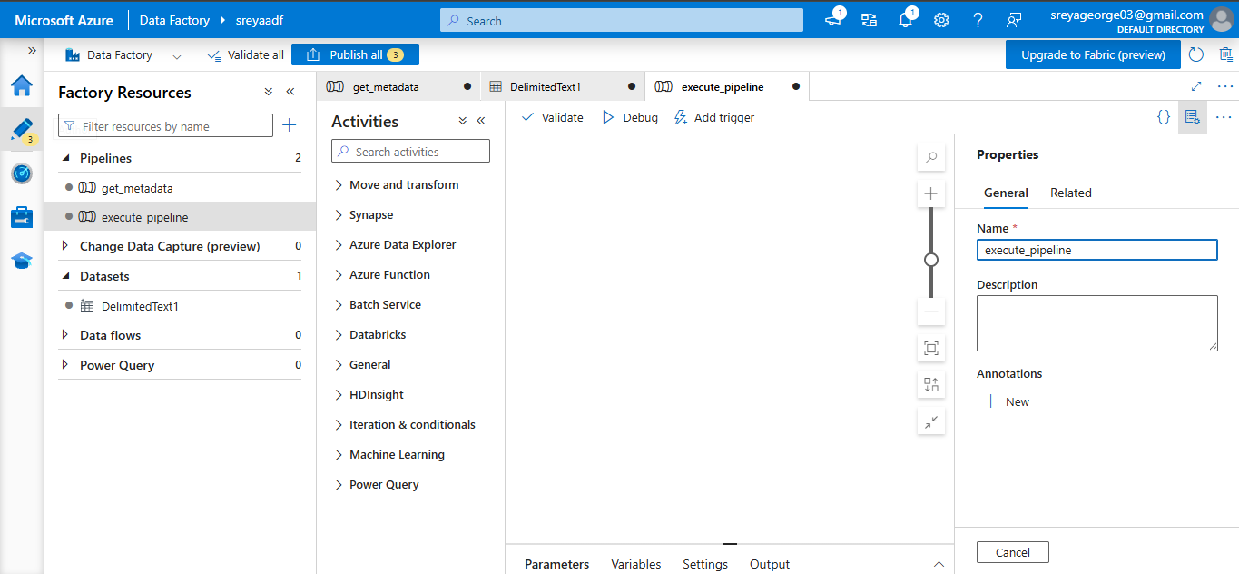
Select execute pipeline,drag and paste it
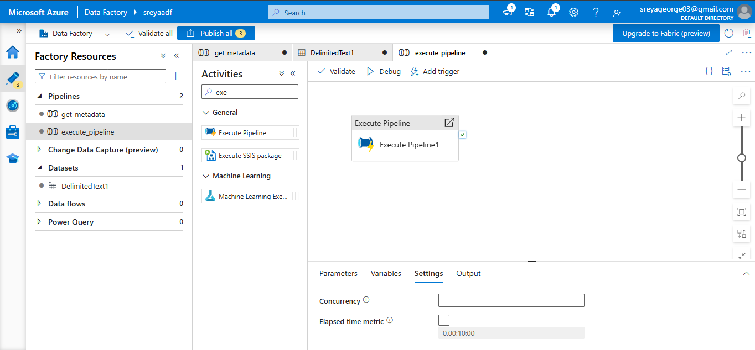
Select any pipeline from execute pipeline setting,I selected a copy data pipeline

